Name: **ABHISHEK SHETE**

**Target test**

* 1. **Import the dataset and do usual exploratory analysis steps like checking the structure & characteristics of the dataset**.

SELECT table_name, column_name, data_type

FROM Target_test.INFORMATION_SCHEMA.COLUMNS

where table_name = 'customers'

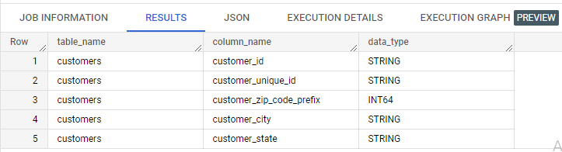

SELECT table_name, column_name, data_type

FROM Target_test.INFORMATION_SCHEMA.COLUMNS

where table_name = 'geolocation'

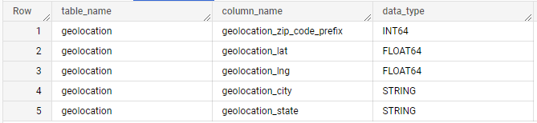

SELECT table_name, column_name, data_type

FROM Target_test.INFORMATION_SCHEMA.COLUMNS

where table_name = 'order_items'

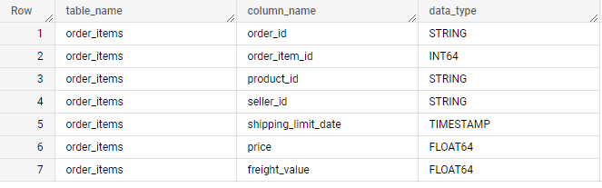

SELECT table_name, column_name, data_type

FROM Target_test.INFORMATION_SCHEMA.COLUMNS

where table_name = 'order_reviews'

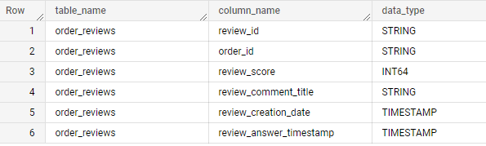

SELECT table_name, column_name, data_type

FROM Target_test.INFORMATION_SCHEMA.COLUMNS

where table_name = 'orders'

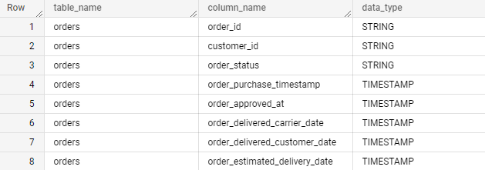

SELECT table_name, column_name, data_type

FROM Target_test.INFORMATION_SCHEMA.COLUMNS

where table_name = 'payments'

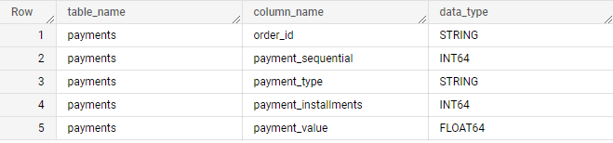

SELECT table_name, column_name, data_type

FROM Target_test.INFORMATION_SCHEMA.COLUMNS

where table_name = 'products'

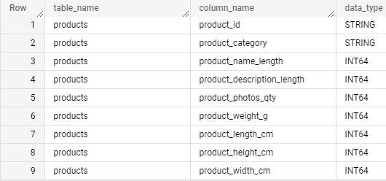

SELECT table_name, column_name, data_type

FROM Target_test.INFORMATION_SCHEMA.COLUMNS

where table_name = 'sellers'

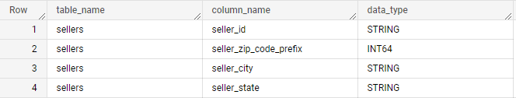

* 1. **Time period for which the data is given**

SELECT MIN(order_purchase_timestamp), MAX(order_purchase_timestamp)

FROM Target_test.orders

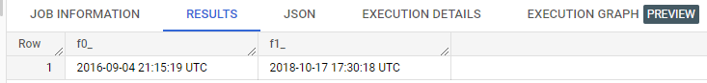

* 1. **Cities and States of customers ordered during the given period**

select distinct customer_city as City, customer_state as State

from `Target_test.customers`

where customer_id IN

(

select customer_id

 from `Target_test.orders`

)

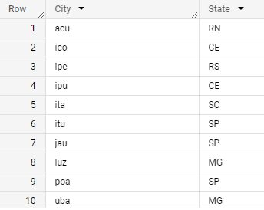

2. In-depth Exploration:

2.1 Is there a growing trend on e-commerce in Brazil? How can we describe a complete scenario? Can we see some seasonality with peaks at specific months?

SELECT EXTRACT(YEAR FROM DATETIME(order_purchase_timestamp)) as Year,

EXTRACT(MONTH FROM DATETIME(order_purchase_timestamp)) as Month,

COUNT(order_id) AS Orders_placed

from `Target_test.orders`

GROUP BY 1,2

ORDER BY 1,2

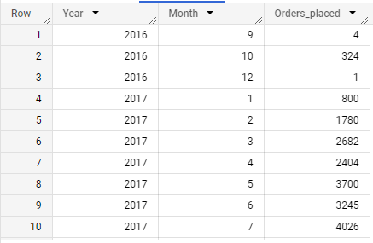

2.2 What time do Brazilian customers tend to buy (Dawn, Morning, Afternoon or Night)?

select

case

 when Hour <= 6 then 'DAWN'

 when 7 <= Hour AND Hour <= 12 then 'MORNING'

 when 13 <= Hour AND Hour <= 18 then 'AFTERNOON'

 when 19 <= Hour AND Hour <= 23 then 'NIGHT'

 END as Time_of_day, SUM(Orders) as Orders_placed

FROM (select count(*) as Orders, EXTRACT(Hour from datetime(order_purchase_timestamp)) as Hour

from `Target_test.orders`

GROUP BY 2)

GROUP BY 1

ORDER BY 2

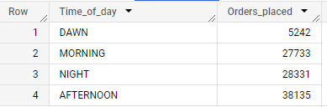

The above table shows the maximum orders placed in “AFTERNOON”

3. Evolution of E-commerce orders in the Brazil region

3.1 Get month on month orders by states.

SELECT C.customer_state AS state,EXTRACT(month FROM

O.order_purchase_timestamp) AS month, COUNT(O.order_id) AS orders_count

FROM `Target_test.orders` O

JOIN `Target_test.customers` C

ON O.customer_id = C.customer_id

group by 1,2

ORDER BY STATE, MONTH

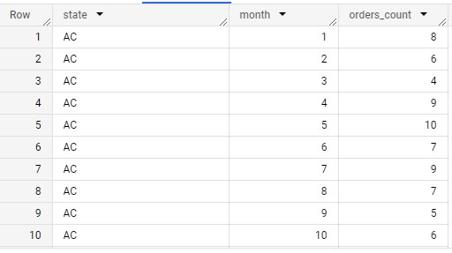

3.2 Distribution of customers across the states in Brazil

select customer_state as State, count(customer_id) as customer_count

from Target_test.customers

GROUP BY 1

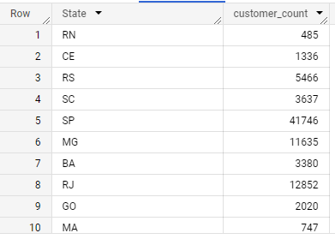

4. Impact on Economy: Analyze the money movement by e-commerce by looking at order prices, freight and others.

4.1 Get % increase in cost of orders from 2017 to 2018 (include months between Jan to Aug only) - You can use “payment_value” column in payments table

WITH tvalue AS (

SELECT ROUND(SUM(payment_value)) AS VAL, EXTRACT(YEAR FROM

o.order_purchase_timestamp) AS YEAR

FROM `Target_test.payments` p

JOIN `Target_test.orders` O

ON P.order_id = O.order_id

WHERE EXTRACT(MONTH FROM O.order_purchase_timestamp) IN (1,2,3,4,5,6,7,8)

 AND

 EXTRACT(YEAR FROM O.order_purchase_timestamp) IN (2017,2018)

GROUP BY 2

ORDER BY 2

)

SELECT ROUND((((SUM(t2.val) - SUM(t1.val)) / SUM(t1.val)) * 100), 2) AS

increase_percentage

FROM tvalue t1, tvalue t2

WHERE t1.Year = 2017 AND t2.Year = 2018



4.2 Mean & Sum of price and freight value by customer state

SELECT c.customer_state AS State,

 ROUND(SUM(oi.price),2) AS sum_price, ROUND(AVG(oi.price),2) AS mean_price,

 ROUND(SUM(oi.freight_value),2) AS sum_freight,

ROUND(AVG(oi.freight_value),2) AS mean_freight

FROM `Target_test.order_items` oi

JOIN `Target_test.orders` o

ON oi.order_id = o.order_id

JOIN `Target_test.customers` c

ON o.customer_id = c.customer_id

GROUP BY State

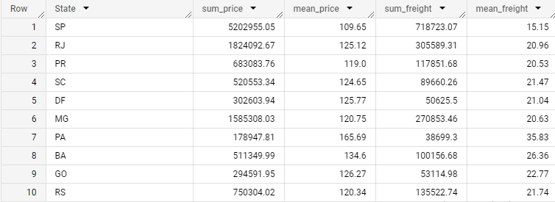

5. Analysis on sales, freight and delivery time

5.1 Calculate days between purchasing, delivering and estimated delivery

SELECT order_id,

 DATE_DIFF( order_delivered_customer_date, order_purchase_timestamp,

day) AS actual_delivery_days,

 DATE_DIFF( order_estimated_delivery_date, order_purchase_timestamp, day)

AS estimated_delivery_days

FROM `Target_test.orders`

WHERE order_status = 'delivered'

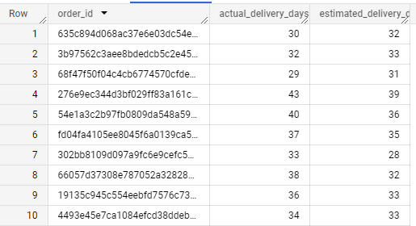

5.2 Find time_to_delivery & diff_estimated_delivery. Formula for the same given below:

* Time_to_delivery = order_delivered_customer_date-order_purchase_timestamp

* diff_estimated_delivery = order_estimated_delivery_date order_delivered_customer_date

SELECT order_id,

DATE_DIFF(order_delivered_customer_date, order_purchase_timestamp, DAY) AS delivery_time,

DATE_DIFF(order_estimated_delivery_date, order_delivered_customer_date,

DAY) AS diff_estimated_delivery

FROM `Target_test.orders`

WHERE order_status = 'delivered'

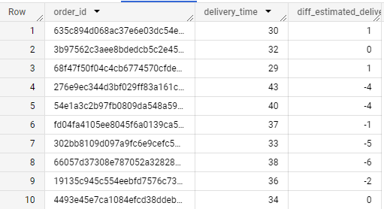

5.3 Group data by state, take mean of freight_value, time_to_delivery, diff_estimated_delivery

SELECT c.customer_state AS STATE,

ROUND(AVG(oi.freight_value)) AS mean_freight_value,

ROUND(AVG(DATE_DIFF(order_delivered_customer_date,

order_purchase_timestamp, DAY))) AS mean_time_to_delivery,

ROUND(AVG(DATE_DIFF(order_estimated_delivery_date,

order_delivered_customer_date, DAY))) AS mean_diff_estimated_delivery

FROM `Target_test.customers` c

JOIN `Target_test.orders` o

ON c.customer_id = o.customer_id

JOIN `Target_test.order_items` oi

ON o.order_id = oi.order_id

WHERE o.order_status = 'delivered'

GROUP BY 1

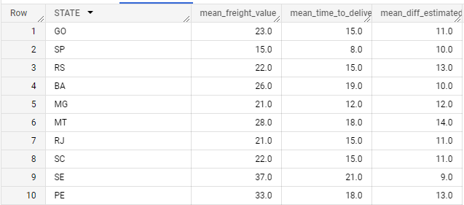

5.4 Sort the data to get the following:

5.5 Top 5 states with highest/lowest average freight value - sort in desc/asc limit 5

SELECT c.customer_state AS STATE,

 ROUND(AVG(oi.freight_value)) AS mean_freight_value,

 ROUND(AVG(DATE_DIFF(order_delivered_customer_date,

order_purchase_timestamp, DAY))) AS mean_time_to_delivery,

 ROUND(AVG(DATE_DIFF(order_estimated_delivery_date,

order_delivered_customer_date, DAY))) AS mean_diff_estimated_delivery

FROM `Target_test.customers` c

JOIN `Target_test.orders` o

ON c.customer_id = o.customer_id

JOIN `Target_test.order_items` oi

ON o.order_id = oi.order_id

WHERE o.order_status = 'delivered'

GROUP BY 1

ORDER BY 2 DESC

LIMIT 5

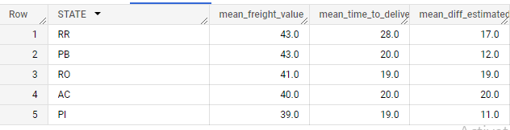

SELECT c.customer_state AS STATE,

 ROUND(AVG(oi.freight_value)) AS mean_freight_value,

 ROUND(AVG(DATE_DIFF(order_delivered_customer_date,

order_purchase_timestamp, DAY))) AS mean_time_to_delivery,

 ROUND(AVG(DATE_DIFF(order_estimated_delivery_date,

order_delivered_customer_date, DAY))) AS mean_diff_estimated_delivery

FROM `Target_test.customers` c

JOIN `Target_test.orders` o

ON c.customer_id = o.customer_id

JOIN `Target_test.order_items` oi

ON o.order_id = oi.order_id

WHERE o.order_status = 'delivered'

GROUP BY 1

ORDER BY 2

LIMIT 5

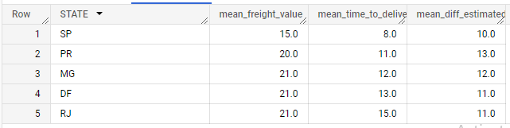

5.6 Top 5 states with highest/lowest average time to delivery.

SELECT c.customer_state AS STATE,

 ROUND(AVG(oi.freight_value)) AS mean_freight_value,

 ROUND(AVG(DATE_DIFF(order_delivered_customer_date,

order_purchase_timestamp, DAY))) AS mean_time_to_delivery,

 ROUND(AVG(DATE_DIFF(order_estimated_delivery_date,

order_delivered_customer_date, DAY))) AS mean_diff_estimated_delivery

FROM `Target_test.customers` c

JOIN `Target_test.orders` o

ON c.customer_id = o.customer_id

JOIN `Target_test.order_items` oi

ON o.order_id = oi.order_id

WHERE o.order_status = 'delivered'

GROUP BY 1

ORDER BY 3 DESC

LIMIT 5

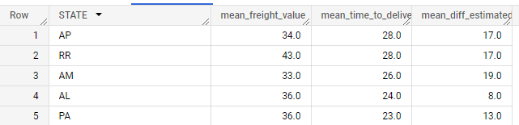

SELECT c.customer_state AS STATE,

 ROUND(AVG(oi.freight_value)) AS mean_freight_value,

 ROUND(AVG(DATE_DIFF(order_delivered_customer_date,

order_purchase_timestamp, DAY))) AS mean_time_to_delivery,

 ROUND(AVG(DATE_DIFF(order_estimated_delivery_date,

order_delivered_customer_date, DAY))) AS mean_diff_estimated_delivery

FROM `Target_test.customers` c

JOIN `Target_test.orders` o

ON c.customer_id = o.customer_id

JOIN `Target_test.order_items` oi

ON o.order_id = oi.order_id

WHERE o.order_status = 'delivered'

GROUP BY 1

ORDER BY 3

LIMIT 5

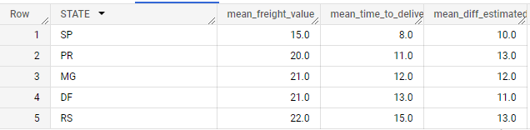

5.7 Top 5 states where delivery is really fast/ not so fast compared to estimated date

SELECT c.customer_state AS STATE,

 ROUND(AVG(oi.freight_value)) AS mean_freight_value,

 ROUND(AVG(DATE_DIFF(order_delivered_customer_date,

order_purchase_timestamp, DAY))) AS mean_time_to_delivery,

 ROUND(AVG(DATE_DIFF(order_estimated_delivery_date,

order_delivered_customer_date, DAY))) AS mean_diff_estimated_delivery

FROM `Target_test.customers` c

JOIN `Target_test.orders` o

ON c.customer_id = o.customer_id

JOIN `Target_test.order_items` oi

ON o.order_id = oi.order_id

WHERE o.order_status = 'delivered'

GROUP BY 1

ORDER BY 4

LIMIT 5

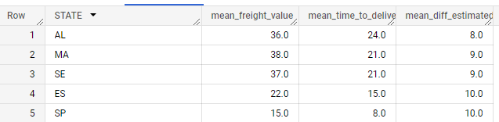

SELECT c.customer_state AS STATE,

 ROUND(AVG(oi.freight_value)) AS mean_freight_value,

 ROUND(AVG(DATE_DIFF(order_delivered_customer_date,

order_purchase_timestamp, DAY))) AS mean_time_to_delivery,

 ROUND(AVG(DATE_DIFF(order_estimated_delivery_date,

order_delivered_customer_date, DAY))) AS mean_diff_estimated_delivery

FROM `Target_test.customers` c

JOIN `Target_test.orders` o

ON c.customer_id = o.customer_id

JOIN `Target_test.order_items` oi

ON o.order_id = oi.order_id

WHERE o.order_status = 'delivered'

GROUP BY 1

ORDER BY 4 DESC

LIMIT 5

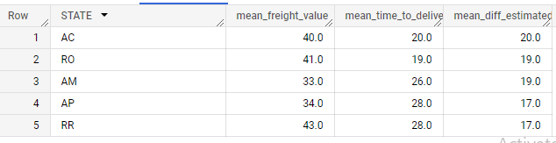

6. Payment type analysis:

6.1 Month over Month count of orders for different payment types

SELECT EXTRACT(MONTH FROM o.order_purchase_timestamp) AS MONTH,

P.payment_type, COUNT(O.order_id) AS Order_count

FROM `Target_test.orders` O

JOIN `Target_test.payments` P

ON O.order_id = P.order_id

GROUP BY 1,2

ORDER BY 1

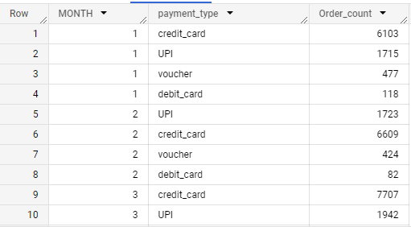

6.2 Count of orders based on the no. of payment installments.

SELECT P.payment_installments, COUNT(O.order_id) AS ORDER_COUNT

FROM `Target_test.orders` O

JOIN `Target_test.payments` P

ON O.order_id = P.order_id

GROUP BY 1 ORDER BY 1

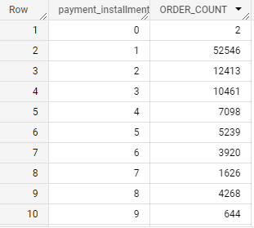

7. Action Insights:

7.1 All and all the data was provided from the date between (2016-09-04 21:15:19 UTC and 2018-10-17 17:30:18 UTC).

7.2 Most of the time orders placed in afternoon.

7.3 136.98 % increase in cost of orders from year 2017 to 2018 as per the data.

7.4 Credit card is most preferred payment option, compared with the credit card which is less preferred.

8. Recommendations:

8.1 the customers who buy the products(orders) with single or maximum three installments they get discounts like cash backs, redeem coupons, offers.

8.2 As shown the majority of the orders are done by credit cards provides special offers like cash backs.

8.3 Giving discounts on orders when there is fall in sales.

8.4 Most of the orders are placed in afternoon time so that flash sales, bonus offers, short term discounts should be provided during the same time.